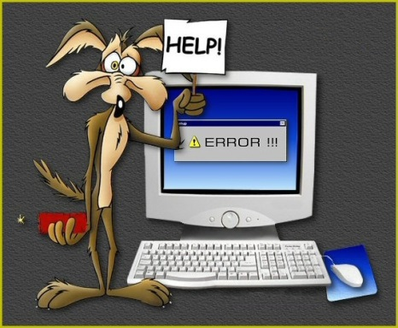Syntax Errors and Runtime Errors (Exceptions)

When a program doesn't run, it can be *very* frustrating. Learning how to interpret and fix syntax and runtime errors is an important skill. For each example below, type each example exactly as shown into ~~PyScripter~~ IDLE, run it and *examine the error message* then make corrections until it runs successfully.

**#Problem 1**

answer = true

print(answer)

**#Problem 2**

spam = 42

if spam = 42:

print('Hello!')

**#Problem 3**

print('Hello!')

print('Howdy!')

**#Problem 4**

print('Hello!)

**#Problem 5**

snickers = 'Al'

print('My name is ' + snikers)

**#Problem 6**

class = "algebra"

print( 'I am taking' + class)

**#Problem 7**

myAge = 16

print(type('16')

**#Problem 8**

12 = dozen

print("dozen")

**#Problem 9**

76trombones = "big parade"

print("76trombones")

**#Problem 10**

income = 89,000

print("Your salary is " + income)

**#Problem 11**

print(len(snickerdoodle)

**#Problem 12**

answer = "15 dollars"

print(int(answer))

**#Problem 13**

minimumWage = input("What is the minimum wage in Washington State?")

hours = input("How many hours did you work today?")

payToday = minimumWage * hours

print("I earned $" + payToday)

**# Problem 1**

answer = True

print answer

**# Problem 2**

spam = 42

if spam == 42:

print 'Hello!'

**# Problem 3**

print 'Hello!'

print 'Howdy!'

**# Problem 4**

print 'Hello!'

**# Problem 5**

snickers = 'Al'

print 'My name is ' + snickers

**# Problem 6**

className = "algebra"

print 'I am taking ' + className

**# Problem 7**

myAge = 16

print(type(myAge))

**# Problem 8**

twelve = "dozen"

print(twelve)

**# Problem 9**

seventy_six_trombones = "big parade"

print seventy_six_trombones

**# Problem 10**

income = 89000

print "Your salary is " + str(income)

**# Problem 11**

print len('snickerdoodle')

**# Problem 12**

answer = 15

print(str(answer) + " dollars")

**# Problem 13**

minimumWage = input("What is the minimum wage in Washington State?")

hours = input("How many hours did you work today?")

payToday = minimumWage * hours

print "I earned $" + str(payToday)